How To Use Test Pool Parser

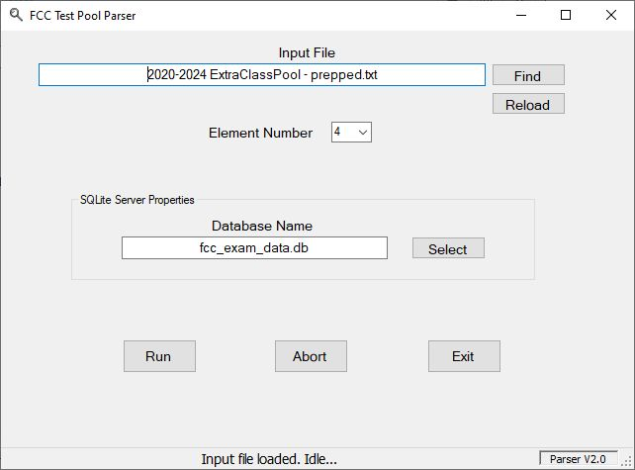

Load the text file

Near the upper right is the “Find” button. Click it and browse your way to the text file with the pool questions. If you followed my naming convention, it’ll be the one ending in “ – prepped”. Below that is the “Reload” button. If you edit the file manually you will need to reload it as the cleaner does not know you changed things. The program will keep track of the document location if you close the program and reopen it.

The program will try to determine the element number if you left the header line in the document. Either way, verify that the proper element number is shown as this is the key to the database table entries. If you use the wrong element number it’ll overwrite the info for that element.

Load the database file location

You’ll see the “Select” button next to the Database Name box. Click it and browse to the location of the SQLite database file containing the question data.

Running the program

Running the parser is simply loading the text file and then clicking the “Run” button. When the program has finished the status label at the bottom of the window will declare it finished and how many questions were parsed from the source file.

In case of hiccups

If there are problems with a question, the program will throw up a messagebox with information including the question number (i.e., “T2B3”). Scan through the source document for the offending question and locate the error in the text. Once you have fixed that, save it and then click the “Reload” button so that you have updated the in-memory copy of the text.

Once you get a clean run with the parser you are ready to create exams.

# # #